1. Introduction

My project is Georgia Gifts. It is a small giftshop that sells nicks and nacks and customized personal gifts. It will feature a products page, a page about the company, and a shopping cart.

1. User interface

The user interface will be the same as Georgia Gifts React mobile user interface. The user interface allows the user to get to the most popular products with the least amount of clicks. It shows them what they are most likely to be after first and the least likely item last. 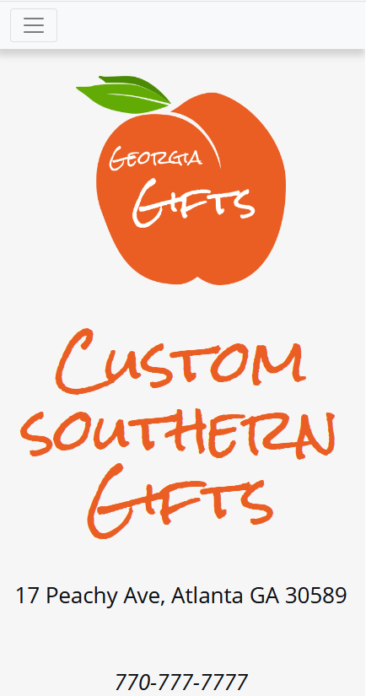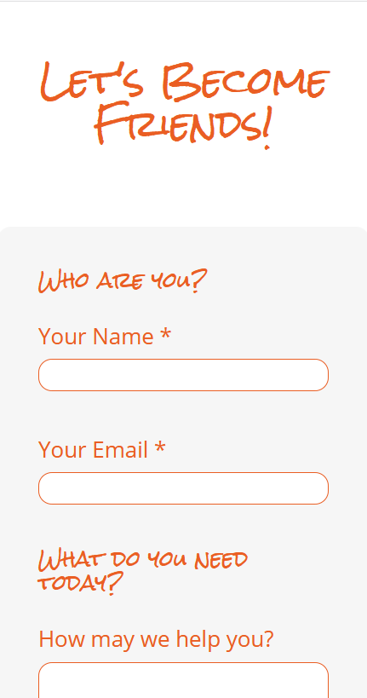

3.Navigation Structure

My navigation will be handled using react navigator in app.js. User will navigate using the draw navigator. The interface is set up to reduce the amount of click/navigating the users need to do. Trying to provide the right content at the right time to reduce the need of navigating.